by Pratt's, which, though not of very great antiquity, occupies curious old-world premises just off St. James's Street. This quaint and agreeable little club, still a flourishing institution, appears to have been founded about 1841; the old manuscript records of elections still exist. Though Pratt's has recently been reorganized, its distinctive features have not been impaired, and the house remains much in its original condition—the kitchen downstairs, with its old-fashioned open fire, quaint dresser filled with salmon-fly plates, old-world furniture and prints, forming a delightful relic of the past. A curious niche in this room would seem to have once served as a receptacle for cards or dice, in the days when the house was used for gambling, and raids by the authorities were common.

Next to the kitchen is the dining-room, in which is a long table; the walls here are hung with old prints of the time when the club was founded. Both this room and the kitchen have very curious mantelpieces, the upper portions of which are formed of classical friezes which would seem to have been brought here from some old mansion. Throughout the quaint little building are cases of stuffed birds and fish, and the accessories and general appearance produce a singular effect not lacking in old-world charm.

Pratt's formerly opened only late in the evening, but its hours now admit of members lunching indeed, whilst great care has been taken to preserve the original spirit of the club, many modern improvements unobtrusively carried out make it a most comfortable resort. Whilst the convenience of members has been studied by the addition of four bedrooms.

By far the most interesting of the old dining clubs was the Sublime Society of Beefsteaks, founded about 1735 by Rich, the famous harlequin and machinist of Covent Garden Theatre. At first it consisted of twenty-four members, but the number was afterwards increased. Hogarth, Wilkes, and many other celebrated men, were members of this society, which had many curious customs.

Its officials consisted of a President of the Day, Vice-President, Bishop, Recorder, and Boots. The meetings were originally held in a room at Covent Garden Theatre. The President took his seat after dinner throughout the season, according to the order in which his name appeared on "the rota." He was invested with the badge of the society by the Boots. His duty was to give the chartered toasts in strict accordance with the list before him; to propose all resolutions that had been duly made and seconded; to observe all the ancient forms and customs of the society; and to enforce them on others. He had no sort of power inherent in his position on the contrary, he was closely watched and sharply pulled up if he betrayed either ignorance or forgetfulness on the smallest matter of routine connected with his office. In fact, he was a target for all to shoot at.

A Beefeater's hat and plume hung on the right-hand side of the chair behind him, and a three-cornered hat (erroneously believed to have belonged to Garrick) on the left. When putting a resolution, the President was bound to place the plumed hat on his head and instantly remove it. If he failed in one or the other act, he was equally reminded by being called to order in no silent terms. The most important obligation imposed on him was the necessity of singing, whether he could sing or not, the song of the day.

The Vice was the oldest member of the society present, and had to carry out the President's directions without responsibility. The Bishop sang the grace and the anthem. The most important official of all was the Recorder. He had to rebuke everybody for offences, real or imaginary, and with him lay the duty of delivering "the charge" to each newly elected member, which was a burlesque function. The Boots was the last elected of the members, and there was a grave responsibility attached to his office. He was the fag of the brotherhood, and had to arrive before the dinner-hour, not only to decant the wine, but to fetch it from the cellar. This latter custom was persevered in until the destruction of the old Lyceum by fire, and was only then abandoned by reason of the inaccessibility of the cellar, when the society returned to the new theatre, the rebuilt Lyceum, in 1838. No one was exempted from this ordeal, and woe to him who shirked or neglected it. The greatest enjoyment seemed to be afforded, both to members and guests, by summoning Boots to decant a fresh bottle of port at the moment when a hot plate and a fresh steak were placed before him. The Duke of Sussex was Boots from the date of his election (April, 1808) to April, 1809, when a

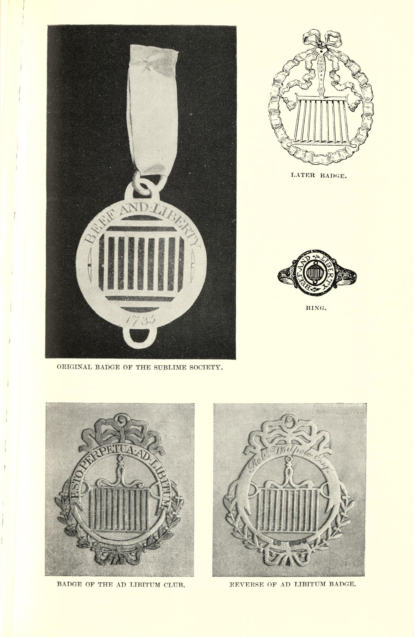
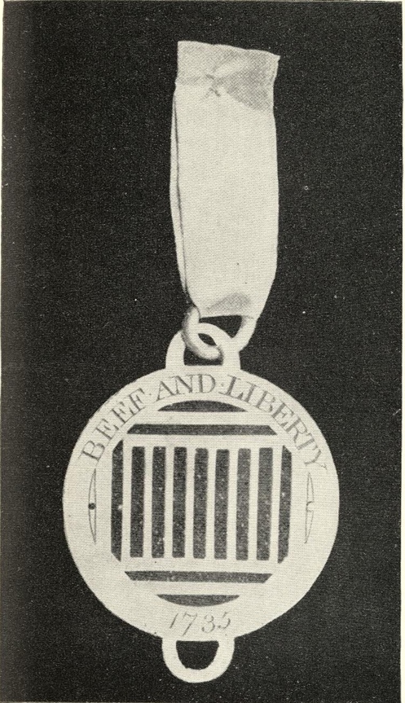
Original Badge of the Sublime Society.

Later Badge.
Ring.
Badge of the Ad Libitum Club.
Reverse of Ad Libitum Badge.

